Trash Robot
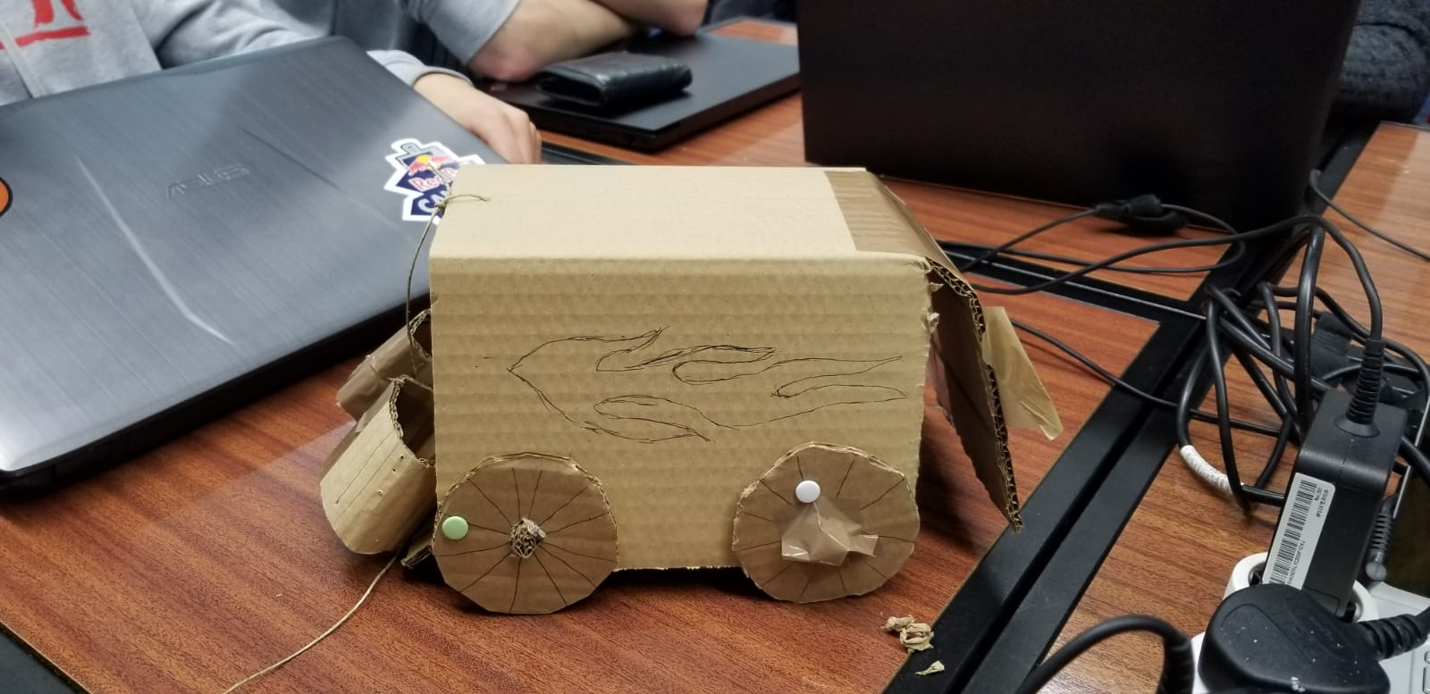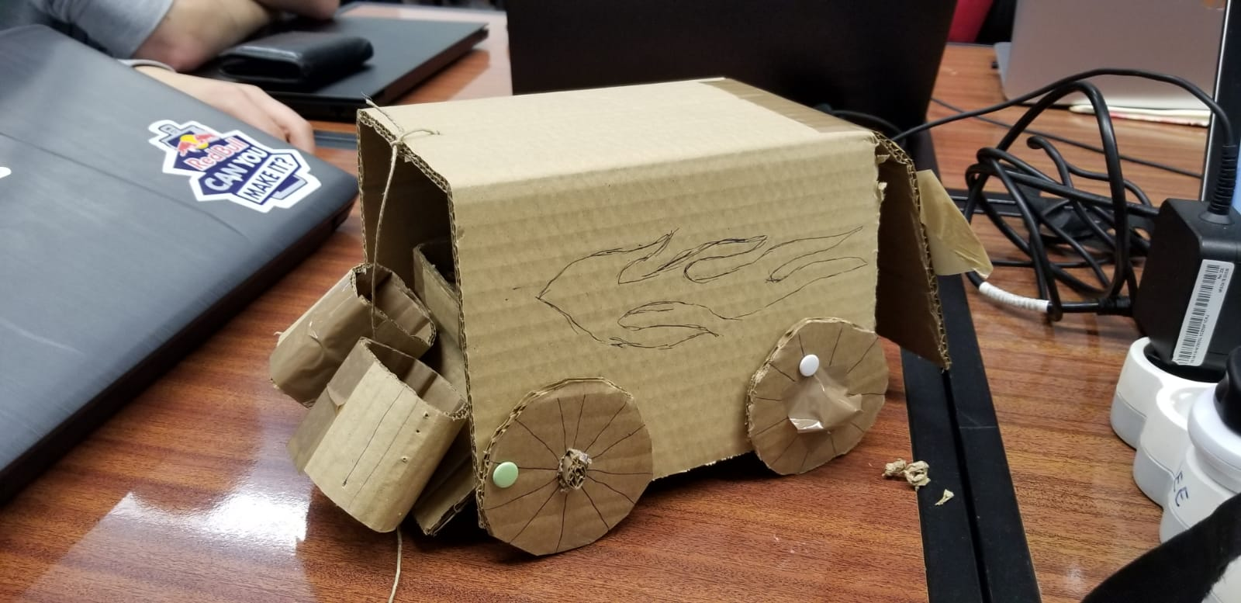

Sponsor
Insert the link to the project sponsor here

Project Summary
The goal is to …
The project requirements are:
- … (specify here your project requirements);
- Comply with the following EU Directives:
  - Machine Directive (2006/42/CE 2006-05-17);
  - Electromagnetic Compatibility Directive (2004/108/EC 2004 12 15);
  - Low Voltage Directive (2014/35/EU 2016-04-20);
  - Radio Equipment Directive (2014/53/EU 2014-04-16);
  - Restriction of Hazardous Substances (ROHS) in Electrical and Electronic Equipment Directive (2002/95/EC 2003-01-27);
- Mandatory adoption and use of the International System of Units (The NIST International Guide for the use of the International System of Units)
- Use open source software and technologies.

Participants
Institution: Instituto Superior de Engenharia do Porto
Team N.: 2
Students:
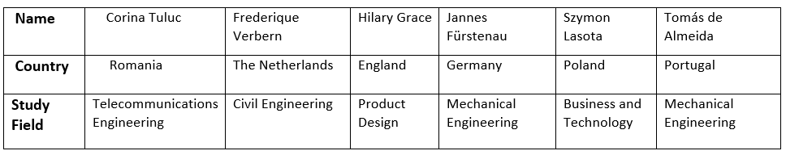
Panel of Supervisors:
- Jorge Justo (jfj 'at' isep 'dot' ipp 'dot' pt)
- Maria Benedita Malheiro (mbm 'at' isep 'dot' ipp 'dot' pt)
- Maria Cristina Ribeiro (mcr 'at' isep 'dot' ipp 'dot' pt)
- Manuel Silva (mss 'at' isep 'dot' ipp 'dot' pt)
- Paulo Ferreira (pdf 'at' isep 'dot' ipp 'dot' pt)
- Pedro Barbosa Guedes (pbg 'at' isep 'dot' ipp 'dot' pt)
Client:
- Client Name, email, etc.

Contents
Project Planning: Deadlines, Tasks, Gantt chart, Task allocation
Logbook: Weekly Report, Meetings, Activities
Report: Report
Deliverables: Links to all deliverables

Contacts
- Student 1 Frederique Verberne, fred.verberne@hotmail.com
- Szymon Lasota, lasota.szymon97@gmail.com
- Jannes Fürstenau, jannes_fuerstenau@gmx.net
- Hilary Grace, n0749212@ntu.ac.uk
- Student 5 Name, username@mailserver, facebook, twitter, etc.

Utilities
- DokuWiki Syntax
- Videos on how to use DokuWiki

Acknowledgements
- Sponsor (sponsor)
- Eng.º Vítor Costa Cerqueira, DEE, ISEP (wiki installation and management)
- Prof. João Correia Lopes, DEI, FEUP (wiki template)
— EPS@ISEP Wiki Template 2012-01-15 15:35

